
REPUBLIC OF GHANA

COMPOSITE BUDGET

FOR 2023-2026

PROGRAMME BASED BUDGET ESTIMATES

FOR 2023

CAPE COAST METROPOLITAN ASSEMBLY

PART A: STRATEGIC OVERVIEW OF THE ASSEMBLY

1.0 ESTABLISHMENT OF THE METROPOLIS
The Cape Coast Metropolitan Assembly is one of the twenty-two (22) Administrative Districts within the Central Region with Cape Coast as the Administrative Capital. The Assembly was initially created as a Municipal Assembly by LI 1373 in 1988 and eventually elevated to Metropolitan Status in February, 2007 by LI 1927.
1.2 POPULATION SIZE AND DEMOGRAPHICS
The following gives a summary of the population of the Metropolis according to the 2021 National Population and housing census. By 2021 Population and Housing census, the
Population of the Metropolis is 189,925
- Male 92,790(48.86)
- Female 97,135(51.14)
- Urban Population 77%
- Rural Population 23%
- Population Density 1573 persons/km

- THE METROPOLITAN ECONOMY
3.1 AGRICULTURE
About 65% of the population is engaged in agriculture. Commercial farmers are approximately 0.3% and peasants (majority) approximately 62%. The available land (arable land) for agriculture is about 9,000 Ha.
3.2 EDUCATION:
The Metropolis has a school programme which corresponds to the educational system in Ghana made up of basic and tertiary education. Basic Education - This comprise Kindergarten, Primary and Junior High (JHS) and Senior High School
3.3 HEALTH
The Metropolis is endowed with a good number of health facilities, to facilitate access to health care. They include hospitals, Clinics, CHPS compounds etc.

3.4 Tourism
The Metropolis is endowed with an enviable potential that predisposes the area to tourism development. The potential of the Metropolis includes physical, historical and cultural variants that could be developed for conventional tourism. The scenic landscape and multiple ethnic characters make the area a favourable destination for adventure-seeking and exploratory tourists. The celebration of the annual festival of the people, the Fetu Afahye, has always attracted people from within and outside the shores of the country. It has developed over the years into a huge cultural celebration and this has enhanced tourism in the Metropolis.

3.5 Water Supply
Safe water supply and sanitation are essential components of any intervention programme designed to secure sustained family health. Lack of potable water predisposes the population to various preventable diseases such as guinea worm, diarrhoea and cholera.

Fortunately, the Metropolis is quite well served with potable drinking water. All communities in the district are served with pipe-borne water from the conventional treatment plant at Brimsu. Rural supplies forms just 1% of the drinking water system in the Metropolis and these areas are also well catered for. Percentage of Homes with Pipe Borne water is 37.7%. The remaining percentage obtain water supply outside their homes.

3.5 ROAD NETWORK
The Metropolis has a road network totalling 316.12km (Verified Length), which is made up of 201.27 km and 114.85km of paved and unpaved roads respectively.

3.7 FINANCIAL SERVICES
A number of banking and non-banking financial institutions are located in the Metropolis. It has a number of commercial and rural banks and a couple of forex bureaux.
3.9 ENERGY / ELECTRICITY
Over 85% of residents of the Metropolis have access to electricity supply in spite of the intermittent power fluctuations experienced at certain times.
THE KEY DEVELOPMENT ISSUES/CHALLENGES
NO. | SECTORS | DEVELOPMENTAL ISSUES/CHALLENGES
 | Economic Development | - Lack of credit facility/ financial support for traders  - High rate of youth unemployment  - Low level of development of tourism potentials of the district
 | Social Development | - Low access to ICT and telecommunication services
 | Environment, Infrastructure And Human Settlements | - Rampant flooding in communities  - Inaccessibility and poor road network  - Lack of proper site for waste disposal and inadequate number of skip containers and poor maintenance of dumping sites.  - Rampant open defecation  - Frequent sand winning at the beach.
 | Governance, Corruption and Public Accountability | - Inadequate infrastructure for security services  - High incidence of crime and security issues  - Low involvement of women in decision making  - Land litigation and boundary dispute between Cape Coast Metropolis and Abura Asebu Kwamankese District (AAK)

VISION
To be a leading Metropolis with a high standard of living, basic infrastructure and services, and have progressive atmosphere where the hopes and aspirations can be attained and maximized.

MISSION
The Cape Coast Metropolitan Assembly exists to facilitate the development of the Metropolis by harnessing both human and material resources for the provision of basic infrastructure and social services within the context of good governance.
GOAL
The goal of the Assembly is to facilitate the improvement in quality of life of the people in the Metropolis through the equitable provision of basic social services and infrastructure and also the promotion of socio-economic development within the context of good governance and in partnership with key stake-holders.
CORE FUNCTIONS OF THE ASSEMBLY
The Cape Coast Metropolitan Assembly (CCMA) is the highest political and administrative authority in the Metropolis. The Assembly’s functions cover the following areas:
- The preparation of development plans and budgets relating to the approved plans
- Formulating and executing plans, programmes and strategies for the effective mobilisation of resources for the overall development of the Metropolis.
- Promoting and supporting production activity and social development in the Metropolis, and removal of obstacles to initiative and development.
- Initiating programmes for the development of basic infrastructure.
- Developing, improving and managing human settlements and the environment
- Maintaining security and public safety in co-operation with national and local security agencies.
- Ensuring ready access to Courts in the Metropolis for the promotion of justice.

CAPE COAST METROPOLITAN ASSEMBLY ADOPTED POLICY OBJECTIVES

FOCUS AREA | POLICY OBJECTIVE
Economic Development | - Boost revenue mobilization, eliminate tax abuse and improve efficiency
Economic Development | - Accelerate opportunities for job creation
Economic Development | - Diversify and expand the tourism industry for economic development
Social Development | - Enhance inclusive and equitable access to and participate in all education at all levels
Social Development | - Ensure sustainability, equitability and easy accessibility to health care services
Social Development | - Expand social protection interventions to reach all categories of vulnerability
Governance,  Corruption &  Public  Accountability | 1.Deepen Political and Administrative Decentralisation
ENVIRONMENT,  INFRASTRUCTURE  & HUMAN  SETTLEMENT | - Promote Effective Disaster prevention and mitigation
ENVIRONMENT,  INFRASTRUCTURE  & HUMAN  SETTLEMENT | - Prevent environmental pollution

FINANCIAL PERFORMANCE-REVENUE
REVENUE PERFORMANCE- IGF ONLY

ITEM | 2020 |  | 2021 |  | 2022 |  | 2022
 | Budget | Actual | Budget | Actual | Budget | Actual as at 31st August, 2022 | % Performance at 31st Aug 2022
Basic Rate | 3,504.00 | 0.00 | 4,000.00 | 293.15 | 3,000.00 | 0.00 | 0.00
Property Rate | 884,679.43 | 879,656.65 | 944,155.67 | 778,444.92 | 934,133.90 | 374,394.40 | 40.07
Fees | 749,727.31 | 735,636.00 | 695,379.60 | 778,482.05 | 983,708.00 | 596,559.60 | 60.64
Fines | 15,050.00 | 11,756.00 | 15,200.00 | 93,433.00 | 220,000.00 | 166,314.00 | 75.59
Licenses | 731,485.25 | 722,952.35 | 1,156,058.50 | 923,557.76 | 1,403,107.00 | 627,723.80 | 44.73
Land | 637,952.61 | 633,747.76 | 728,116.18 | 591,716.50 | 646,454.76 | 444,879.47 | 68.81
Rent | 430,783.13 | 391,510.00 | 859,719.18 | 615,155.43 | 804,240.00 | 371,343.00 | 46.17
Miscellaneous | 12,300.60 | 11,400.00 | 17,700.00 | 33,397.20 | 0.00 | 0.00 | 0.00
Total | 3,465,482.33 | 3,386.658.76 | 4,420,329.13 | 3,814,480.01 | 4,994,643.66 | 2,581,214.27 | 51.67

FINANCIAL PERFORMANCE – REVENUE
REVENUE PERFORMANCE TREND- ALL REVENUE SOURCES
ITEM | 2020 |  |  | 2021 |  |  | 2022 |  |  | 2022
 | Budget | Actual | Budget |  | Actual | Budget |  | Actual - 31st, August, 2022 | % Performance 31st Aug. 2022
IGF | 3,465,482.33 | 3,386,658.76 | 4,420,329.13 |  | 3,814,480.01 | 4,994,643.66 |  | 2,581,214.27 | 51.67
Compensation transfer | 3,322,609.25 | 4,909,273.89 | 5,044,629.36 |  | 4,637,874.29 | 4,393,704.55 |  | 3,995,806.29 | 90.94
Goods and Services transfer | 157,081.75 | 123,229.06 | 187,154.00 |  | 106,471.73 | 218,726.00 |  | 69,915.32 | 31.96
Assets Transfer | 0.00 | 0.0 | 0.00 |  | - | 25,180.00 |  | 0.00 | 0.00
DACF | 5,350,320.59 | 2,371,565.86 | 5,704,092 |  | 1,460,005.47 | 5,999,056.91 |  | 1,245,361.05 | 20.76
School Feeding | 0.00 | 0.00 | 0.00 |  | - | 0.00 |  | 0.00 | 0.00
DDF | 422,772.35 | 415,146.24 | 1,696,198.96 |  | 1,696,199.00 | 1,593,622.27 |  | 1,532,924.26 | 96.19
UDG | 0.00 | 0.00 | 0.00 |  | - | 0.00 |  | 0.00 | 0.00
MAG | 118,482.06 | 117,940.01 | 53,786.45 |  | 53,620.32 | 26,981.21 |  | 26,981.21 | 100.00
FOSU LAGOON | 0.00 | 0.00 | 0.00 |  | - | 0.00 |  | 0.00 | 0.00
GIZ | 0.00 | 0.00 | 0.00 |  | - | 0.00 |  | 0.00 | 0.00
TREE | 0.00 | 0.00 | 0.00 |  | - | 0.00 |  | 0.00 | 0.00
UNICEF-CHILD RIGHT | 35,000.00 | 32,500.00 | 70,000.00 |  | 56,460.00 | 35,000.00 |  | 17,500.00 | 50.00
UNICEF-URBAN SUPPORT | 86,532.00 | 88,032.00 | 120,000.00 |  | 217,867.00 | 300,000.00 |  | 157,721.93 | 8.10
CAPE COAST BON PARTNERSHIP | - | - | 10,905.75 |  | 10,905.75 | 0.00 |  | 0.00 | 0.00
UN HABITAT | - | - | 71,160.00 |  | 36,520.00 | 50,000.00 |  | 0.00 | 0.00
TOTAL | 12,958,280.33 | 11,444,345.82 | 17,378,255.65 |  | 12,090,403.57 | 17,636,914.39 |  | 9,627,424.33 | 54.59

NB:
Unicef Urban Sanitation includes Balance b/f of GH¢80,121.93
DACF- RFG includes a Balance b/f of GH¢388,875.27

FINANCIAL PERFORMANCE-EXPENDITURE
EXPENDITURE PERFORMANCE (ALL DEPARTMENTS) GOG ONLY
Expenditure | 2020 |  | 2021 |  | 2022 |  | 2022
 | Budget | Actual | Budget | Actual | Budget | Actual as at 31st August, 2022 | % Perf. at 31st August, 2022
Compensation | 3,322,609.25 | 4,909,273.89 | 5,044,629.36 | 4,637,874.29 | 4,393,704.42 | 3,995,806.29 | 90.94
Goods and Services | 157,081.75 | 123,229.06 | 187,154.00 | 51,311.69 | 218,726.00 | 9,000.00 | 4.11
Assets | 0.00 | 0.00 | 0.00 | - | 25,180.00 | 0.00 | 0.00
Total | 3,479,691.00 | 5,032,502.95 | 5,231,783.36 | 4,689,185.98 | 4,637,610.42 | 4,004,806.29 | 86.35

FINANCIAL PERFORMANCE-EXPENDITURE
EXPENDITURE PERFORMANCE (ALL DEPARTMENTS) IGF ONLY
Expenditure | 2020 |  | 2021 |  | 2022 |  | %  performance  as at 31st  August, 2022
 | Budget | Actual | Budget | Actual | Budget | Actual as at 31st August. 2022 | %  performance  as at 31st  August, 2022
Compensation | 698,390.91 | 606,959.06 | 855,703.95 | 770,327.26 | 741,575.08 | 473,964.78 | 54.48
Goods and Services | 2,551,091.42 | 2,604,386.30 | 3,114,978.48 | 3,131,112.22 | 3,386,873.68 | 2,125,443.01 | 48.2
Assets | 216,000.00 | 137,376.70 | 449,646.70 | 21,236.90 | 866,194.80 | 121,018.90 | 11.73
Total | 3,465,482.33 | 3,348,722.06 | 4,420,329.13 | 3,922,676.38 | 4,994,643.66 | 2,720,426.69 | 42.81

FINANCIAL PERFORMANCE-EXPENDITURE
EXPENDITURE PERFORMANCE (ALL DEPARTMENTS) ALL FUNDING SOURCES
EXPENDITURE | 2020 |  | 2021 |  | 2022 |  | % Perf Aug.  2022
EXPENDITURE | Budget | Actual | Budget | Actual | Budget | Actual as at August, 2022 | % Perf Aug.  2022
Compensation | 4,020,999.51 | 5,526,542.08 | 5,900,333.31 | 5,603,553.35 | 5,135,279.50 | 4,469,770.78 | 87.04
Goods and Services | 5,616,929.55 | 5,004,831.18 | 6,847,576.78 | 4,246,384.38 | 6,862,372.76 | 3,123,070.51 | 45.51
Assets | 3,320,349.81 | 1,822,247.33 | 4,630,345.56 | 1,523,220.93 | 5,639,263.20 | 637,341.08 | 11.30
Total | 12,958,278.87 | 12,353,620.59 | 17,378,255.65 | 11,373,158.66 | 17,636,914.39 | 8,230,182.37 | 46.66

2022 BUDGET PROGRAMME PERFORMANCE
Budget Programme | 2022 Budget | Actual as at August, 2022
Management and Administration | 7,645,276.88 | 4,976,743.95
Infrastructure Delivery and Management | 2,785,069.66 | 471,345.10
Social services Delivery | 2,887,288.33 | 1,245,233.29
Economic Development | 2,605,736.49 | 1,292,252.49
Environmental and Sanitation Management | 1,713,543.03 | 244,607.83
TOTAL | 17,636,914.39 | 8,230,182.37

2022 KEY PROJECTS AND PROGRAMMES FROM ALL FUNDING SOURCES
NO | NAME OF PROJECT | AMOUNT BUDGETED | ACTUAL PAYMENT AS AT AUGUST, 2022 | OUTSTANDING BALANCE
 | SOCIAL SERVICE DELIVERY
 | Education, youth and sport management
1 | Replacement of damaged roof at St. Andrews Anglican M/A Basic School at Taido | 12,540.90 | 11,790.88 | -
2 | Rehabilitation of schools within the Metropolis | 40,000.00 | 4,950.00 | -
 | Education, Youth and Sports Management
3 | Rehabilitation of 6 unit classroom block at Dehia | 101,138.34 | 56,239.89 | -
4 | Completion of 3unit classroom block at Brabedze | 21,052.95 | 21,052.95 | -
5 | Final payment for the purchase of 1,782 mono desks | 96,147.69 | 96,147.00 | -
6 | Completion of Accommodation for the Metro Director of Education at 3rd Ridge | 260,647.48 | 103,500.00 | 157,147.48
7 | Support to Teaching and Learning Delivery | 110,230.30 | 50,050.00
 | ECONOMIC DEVELOPMENT
 | Development of Trade & Industries
8 | Purchase of Boom lift Vehicle | 98,880.00 | 98,880.00 | -
9 | Drilling and Mechanization of Borehole at Kotokuraba Market | 40,686.45 | 40,686.45 | -
10 | Electrification and Maintenance of Street Lights | 320,000.00 | 181,471.00
 | ENVIRONMENTAL AND SANITATION MANAGEMENT |  |  | -
10 | Rehabilitation of 10 Seater KVIP at Ankaful | 10,000.00 | 5,000.00 | -
11 | Repair works at Abattoir, Amoakofua | 18,626.05 | 18,576.00
12 | Removal of Acquatic weeds from the Fosu Lagoon | 30,000.00 | 6,000.00
 | TOTAL | 1,159,950.16 | 694,344.17 | 202,045.93

KEY ACHIEVEMENTS (2022)
- 1no.3-Unit Classroom Block at Brabedze Completed.
- Accommodation for the Metro Director of Education at 3rd Ridge at 80% completion stage
- Drilled and Mechanized Borehole at the Kotokuraba Market
- Damaged roof at St. Andrews Anglican M/A Basic School at Taido replaced
- 6-unit classroom block at Dehia rehabilitated
- Boomlift Vehicle purchased
- Distribution of 2,800 Coconut Seedlings to Farmers
- Eighteen (18) Communities sensitised on Child Protection under UNICEF Programme and logistics being provided.
- The Assembly is now second (2nd) in SWIMS Data Entry Case Management in Central Region & Tenth (10th) Nationally

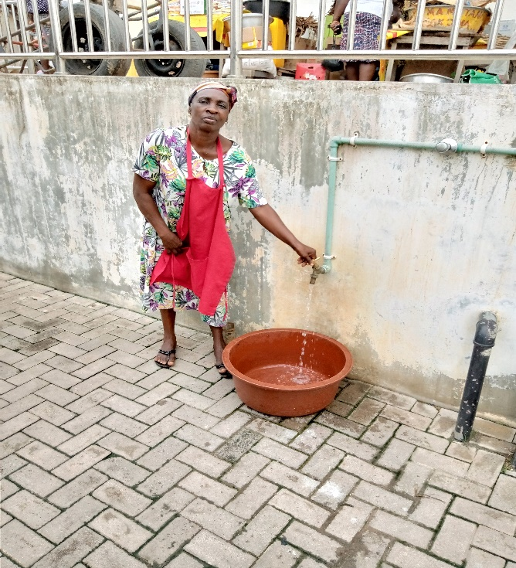
PICTURES OF KEY ACHIEVEMENTS
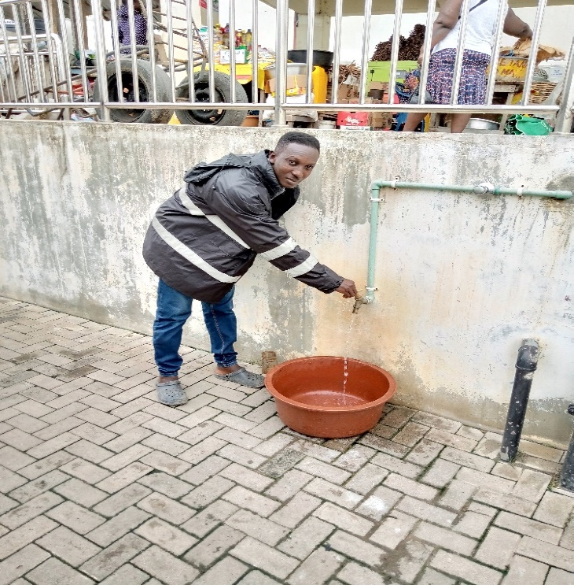

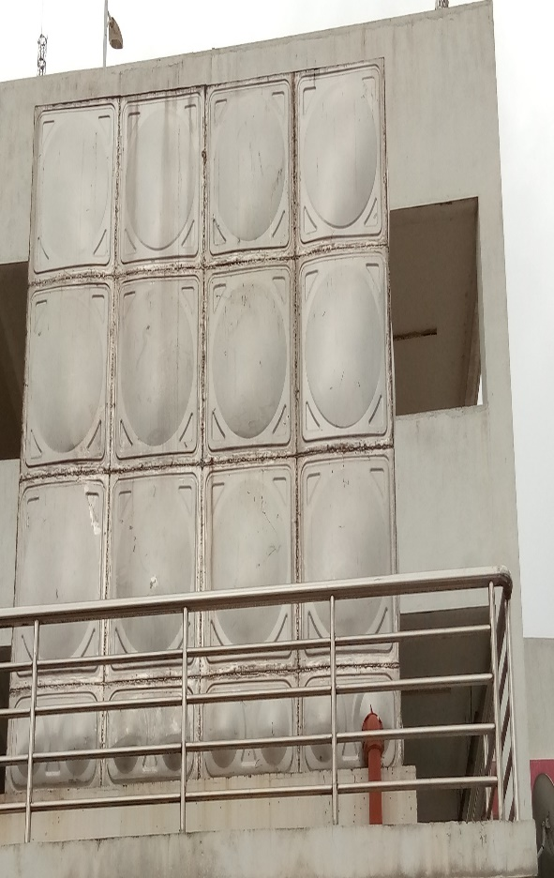
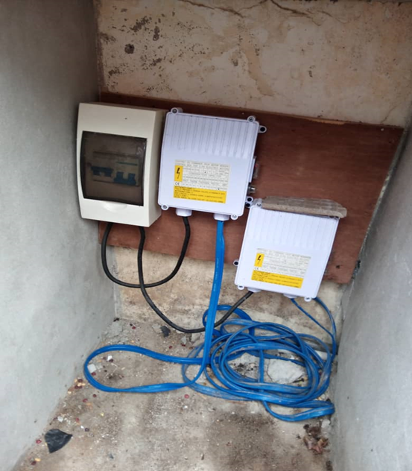

Drilled and mechanized Boreholes at the New Kotokuraba market (IGF)
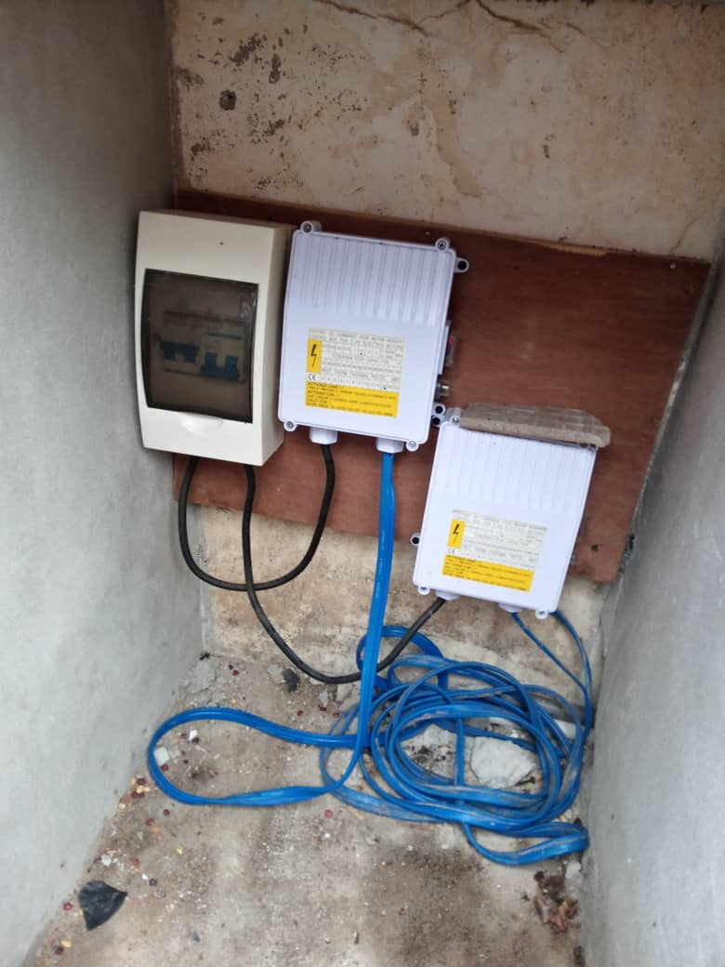
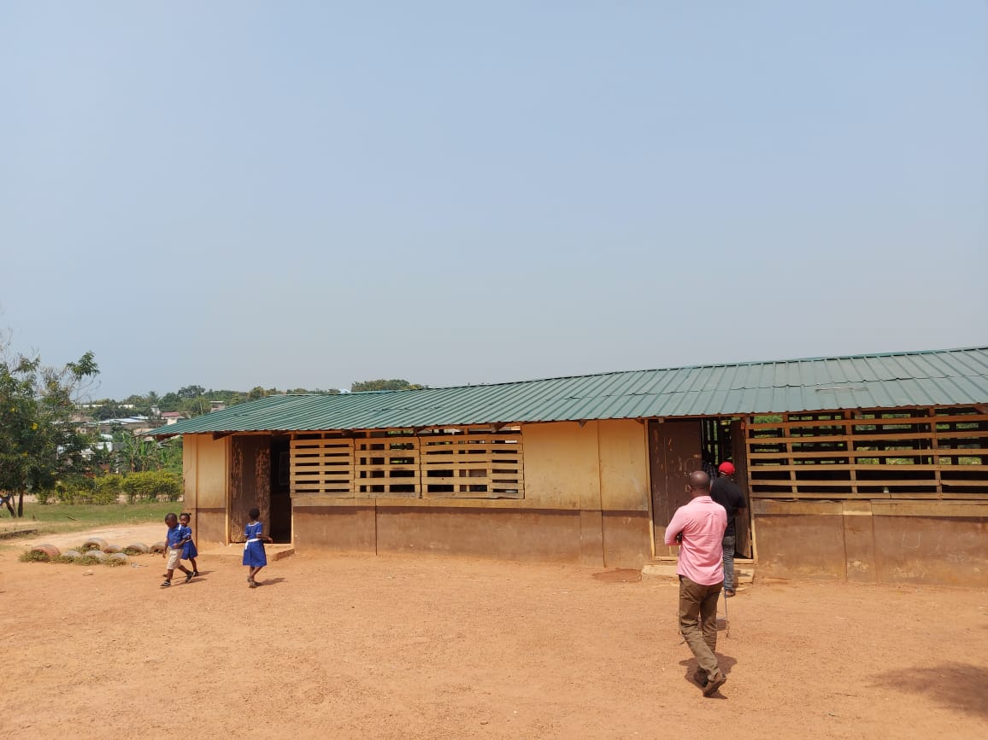

Damaged roof at St. Andrews Anglican M/A Basic School at Taido Completed – IGF

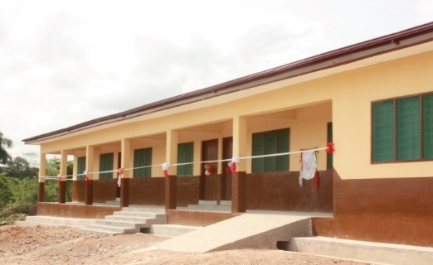

3-Unit Classroom Block at Brabedze completed – DACF- RFG

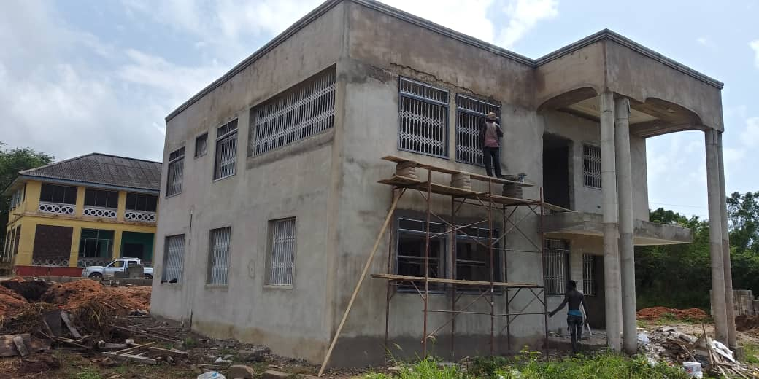

Accommodation Facility at 3rd Ridge- DACF-RFG

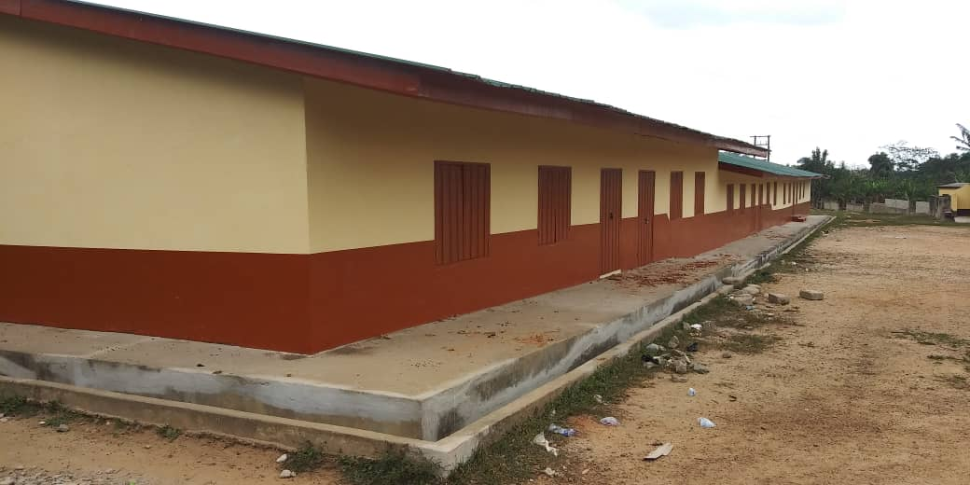
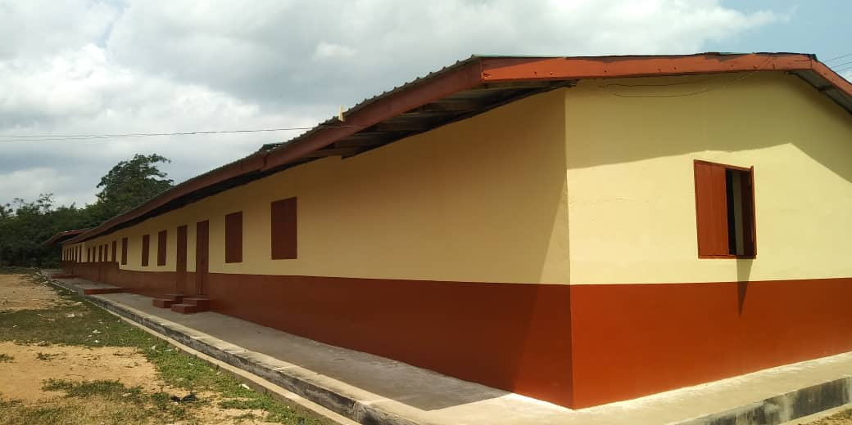

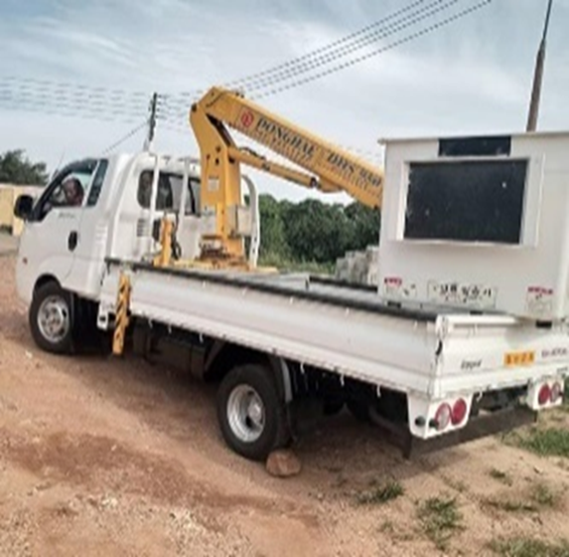
School Block at Dehia Rehabilitated -DACF

BOOM LIFT

Boom lift Vehicle Purchased - DACF
POLICY OUTCOME INDICATORS AND TARGETS
Outcome Indicator Description | Unit of measurement | Previous Year Performance (2021) |  | Current Year’s Performance (2022)
Outcome Indicator Description | Unit of measurement | Target | Actual | Target | Actuals as at August,22
SP1.1 Deepen Local Governance | No. of Stakeholders meeting held | 6 | 4 | 6 | 5
SP1.2 Judicious use of resources and improved adherence to regulations | %Reduction in Audit Queries | 10% | 5% | 10% | -
SP1.2 Revenue Collection and Management improved | % Increase in IGF revenue | 20% | 12.63% | 20% | 8%
SP1.3 Improved staff capacity and service delivery | No. of Staff Trained
SP1.4 Delivery of High Standard Quality Projects | % Increase in projects completed timeously | 100% | 80% | 100% | 60%
SP1.6 Internally Generated Fund increased | % Increase in revenue data | 20% | 12.63% | 20% | 8%
SP1.7 Legal Compliance by Citizens | Number of education and sensitization programmes organised | 2 | 1 | 2 | 1
SP2.2 Clean & Hygienic Environment ensured | % Decrease in filth related diseases | 20% | 14% | 20% | 10%
SP2.2 Child Right Protection and Promotion Programmes & System Ensured | 1.No. of Programmes undertaken  2. % of reported cases settled and managed | 6  90% | 10  86.67% | 10  90% | 8  90%
SP 2.2 Family Tracing & Reunification and Social Enquiries Found Missing Children & Trafficking and Persons With Mental Health (PWMHD) Carried out | No. of Missing Children / Persons Identified.  No. of Children’s families traced and reunified | 20  20 | 43  33 | 30  25 | 15  13
Outcome Indicator Description | Unit of measurement | Previous Year Performance (2021) |  | Current Year’s Performance (2022)
Outcome Indicator Description | Unit of measurement | Target | Actual | Target | Actuals as at August,22
SP3.2 Adherence to Local Plan | % Reduction in illegal structures | 50% | 45% | 70% | 55%
SP3.3 Desilting of Selected Earth Channels Completed | % Reduction in flooding in the Metropolis | 50% | 20% | 50% | -
SP3.4 Effective and Efficient Transport systems ensured | % Increase in direction and access to places | 6% | 4% | 7% | 2%
SP3.4 Regulation of Passenger Transport Service ensured in the Metropolis | % Reduction in Traffic Offenses | 12% | 10% | 15% | 9%
SP4.1 Skills of Youth Enhanced | % Reduction in unemployment | 10% | 8% | 10% | 8%
SP3.2 Security in the Metropolis enhanced | % Reduction in crime rate at night | 20% | 9% | 15% | 12%
SP4.2 Improvement in Crop Production | % Increase in crop yield per acre | 10% | 14% | 20% | 26%
SP4.2 Promotion & Development of life Stock and Poultry for food security ensured | % Increase in consumption of locally produced life stock and poultry products | 20% | 17% | 20% | 16%
SP4.3 Tourism Promotion Achieved | Number of tourism and investment activities organised | 4 | - | 4 | 1
SP5.1Disaster Prevention and Mitigation ensured | % Reduction in disaster cases | 5% | 7% | 10% | 12%
SP5.2 Solid Waste Management achieved | % Reduction in filth in the Metropolis | 10% | 12% | 15% | 15%
SP3.2 Clean & Hygienic Environment Ensured | % Reduction in filth related diseases. | 10% | 10% | 20% | 12%

KEY PERFORMANCE INFORMATION FOR BUDGET PROGRAMMES
Key / Main Outputs | Output Indicator | Pass Years
Key / Main Outputs | Output Indicator | 2021 Budget | 2021 Actual | 2022 Budget | 2022 Actual as at Aug. 22
1.0 MANAGEMENT AND ADMINISTRATION
General Administration
General Assembly Meetings organised | No. of General Assembly meetings organised | 3 | 3 | 3 | 1
Management and HODs meetings organised | No. of Management and HODs meeting held | 14 | 10 | 14 | 8
Official and National Celebrations Organised | No. of events organised | 5 | 5 | 5 | 5
Audit Committee Meetings Organised | No. of Audit Committee Meetings organised | 4 | 4 | 4 | 2
FINANCE AND AUDIT
Accounting software upgraded | The New features of the Software | 1 | 0 | 1 | 0
Valued Books Purchased | No. of value books purchased | 40,000 | 24,080 | 45,000 | 30,000
BUDGETING AND FINANCE
Budget and Rating
Data on businesses updated | No. of new businesses added | 100 | 50 | 100 | 80
Composite Budget Prepared | Composite Budget | 1 | 1 | 1 | 1
3.1 Education, Youth and Sports Mgt
Needy but Brilliant Students supported | No. of Students supported | 50 | 20 | 50 | 30
BECE Mock Examination supported | No. of BECE mock examination held | 1 | 1 | 1 | 1
Damaged Roof at St. Anglican Basic School at Taido replaced | The Repaired roof | 1 | - | 1 | 1
Schools within the Metropolis rehabilitated | No. of Schools Rehabilitated | 5 | 2 | 7 | -
Key / Main Outputs | Output Indicator | Pass Years
 |  | 2021 Budget | 2021 Actual | 2022 Budget | 2022 Actual as at Aug. 22
3.2 Social Welfare and Community Dev’t
Child Rights, Protection & Promotion Programmes Undertaken | No. of Programs Undertaken | 12 | 10 | 12 | 8
Gender Empowerment & Mainstreaming and Sexual & Gender-Based Violence (SGBV Programmes Carried Out | No. of Stakeholders or Communities Engaged. | 30 | 25 | 30 | 10
 | No. of Programs Undertaken | 12 | 7 | 12 | 4
3.3 Health Delivery
CHP’s Compound Rehabilitated | No. of CHPs Rehabilitated | 2 | 0 | 2 | 0
COVID-19 Related Activities Undertaken | No. of Programmes undertaken | 3 | 3 | 3 | 2
Environmental Sanitation Activities Undertaken | No. of Programmes undertaken | 8 | 8 | 8 | 4
4. ECONOMIC DEVELOPMENT
4.1 Dev’t of Trade and Industries
Street light in the Metropolis maintained | No. of Street lights maintained | 100 | 80 | 100 | 50
Markets in the Metropolis maintained | No. of Markets maintained | 4 | 4 | 4 | 3
Youth Trained in Employable Skills | No. of Youth Trained | 150 | 100 | 150 | 50
4.2 Tourism Development
Tourism Related Activities undertaken | No. of Programmes undertaken | 4 | 0 | 4 | 0
4.4 Agricultural Development
Farmers Day Celebration Organized | No. of Programmes undertaken | 1 | 1 | 1 | 0
5. ENVIRONMENTAL AND SANITATION MANAGEMENT
5.2 Waste Management
Public toilets maintained | No. of Public Maintained | 5 | 3 | 5 | 1
WMD Vehicles maintained | No. of WMD Vehicles Maintained | 2 | 2 | 2 | 2
Public Toilets constructed | No. of Public Toilets constructed | 4 | 2 | 4 | 0

2022 SANITATION BUDGET PERFORMANCE
NO | NAME OF ACTIVITY / PROJECT | BUDGET GH¢ | ACTUALS AS AT AUGUST, 2022
 | LIQUID WASTE
1 | Maintenance of Waste Management Vehicle | 30,000.00 | 28,575.00
2 | Fuel Allocation to Waste Management Vehicle | 25,000.00 | 9,788.00
3 | Maintenance of Liquid Waste Disposal Site | 110,000.00 | -
4 | Maintenance of Public Toilet | 10,000.00 | 5,908.74
7 | Rehabilitation of 10-seater KVIP at Ankaful | 10,000.00 | 5,000.00
8 | Construction of 8 Seater W/C Toilet at Adisadel | 105,374.00 | -
9 | Construction of 10 Seater W/C at Nkum | 98,281.00 | -
10 | Repair of Septic Tank at Wesley Girls High School | 11,654.00 | 8,732.40
11 | Repair works at Abattoir, Amoakofua | 18,626.05 | 18,576.00
12 | Provision of submersible pump and electricity connection for various KVIPs in the Metropolis | 56,150.00 | -
13 | Completion of 1 No. 20 Seater WC at Philip Quaicoe Girls School | 11,027.15 | 11,027.00
 | Sub Total | 486,112.20 | 49,244.14
 | SOLID WASTE
1 | Purchase of skip Containers | 100,000.00 | -
2 | Evacuation of Solid Waste | 208,519.13 | 91,907.00
3 | Maintenance of Waste management Official Vehicle | 20,000.00 | 17,980.00
4 | Fuel Allocation to Waste Management Vehicle | 15,000.00 | 14,800
5 | Removal of Aquatic weeds from Fosu Lagoon | 30,000.00 | 6,000
 | Sub Total | 373,519.13 | 130,687.00
 | GRAND TOTAL | 859,631.33 | 179,931.14

2022 DP SUPPORTED PROGRAMMES
NO | MAG – AGRIC | Budget | Actual as at August, 2022
 | Name of operation / Project
1. | Internal Management of Organization | 6,978.00 | 5,164.31
2. | Manpower and Skills Development | 1,024.00 | -
3. | Extension Services | 7,315.00 | 5,363.00
4. | Monitoring and Evaluation of Programme | 6,964.21 | 4,134.00
5. | Data Collection | 4,300.00 | -
6. | Surveillance and Management of Diseases and Pests | 400.00 | -
 | TOTAL | 26,981.21 | 14,661.31

UNICEF CHILD RIGHT AND PROTECTION
Name of operation / Project | Budget | Actual as at August, 2022
Cases Management Using Case Mgt. Tools (CMTs) & Social Welfare Information Management System (SWIMS) | 7,680.00 | 3,840.00
Support for Family Tracing & Reunification and Integration of Thirty (30) Found Missing & Vulnerable Children in Need of Care and Protection With Families, Emergency Medical Bills & NHIS Registration | 11,900.00 | 5,950.00
Communities Awareness & Sensitization in 20 Communities on Child Protection & Family Welfare, Gender- Based Violence and Juvenile Justice | 11,920.00 | 5,960.00
Procurements of Logistics for Effective Office Running, Reporting & Better Social Services Delivery | 3,500.00 | -
TOTAL | 35,000.00 | 15,750.00

UNICEF – URBAN SANITATION PROJECT
NO | Name of operation / Project | Budget | Actual as at August, 2022
1 | Champions Training Workshop | 99,000.00 | 3480.00
2 | Media (Radio) Engagements | 27,000.00 | 15,000.00
3 | Reviewing and Gazetting of CCMA Bye Laws | 20,000.00 | 11,061.93
4 | Mass Registration for Basic Sanitation Funds Application | 35,000.00 | 12,000.00
5 | Landlords Engagement to Construct Latrines through Basic Sanitation Fund | 5,000.00 | 1,320.00
6 | Stakeholder Review Meeting on the Progress Of Urban Sanitation Projects | 10,000.00 | 6,180.00
7 | Networking Meeting with Sanitation Providers | 15,000.00 | 1,500.00
8 | Monthly Review Meetings for Filed Facilitators | 12,000.00 | 4,520.00
9 | Meetings Of MICCS to Review Progress of Project | 2,000.00 | 1,070.00
10 | Facilitators Monthly DSA | 45,000.00 | 32,000.00
11 | Weekly Fuel for Field Activities | 30,000.00 | 16,000.00
 | TOTAL | 300,000.00 | 104,131.93

2022 GOVERNMENT FLAGSHIP PROJECTS / PROGRAMMES
(Assembly’s Contribution)
NO | NAME OF ACTIVITY/PROJECT | BUDGET | Actual as at August, 2022
1 | Provision for final payment for 10 Acres of Land for Warehouse (1D1W) at Efutu | 60,000.00 | 20,000.00
 | TOTAL | 60,000.00 | 20,000.00

OUTLOOK FOR 2023-2026

MMDA ADOPTED POLICY OBJECTIVES FOR 2023
FOCUS AREA | POLICY OBJECTIVE | BUDGET (GH¢)
Economic Development | 1.Boost revenue mobilization, eliminate tax abuse and improve efficiency | 2,743,278.03
Economic Development | - Accelerate opportunities for job creation | 2,743,278.03
Economic Development | - Diversify and expand the tourism industry for economic development | 2,743,278.03
Social Development | - Enhance inclusive and equitable access to and participate in all education at all levels | 3,425,095.13
Social Development | - Ensure sustainability, equitability and easy accessibility to health care services | 3,425,095.13
Social Development | - Expand social protection interventions to reach all categories of vulnerability | 3,425,095.13
Governance,  Corruption &  Public  Accountability | 1.Deepen Political and Administrative Decentralization | 8,749,268.00
Environment,  Infrastructure  & Human  Settlement | - Promote Effective Disaster prevention and mitigation | 5,181,212.35
Environment,  Infrastructure  & Human  Settlement | - Prevent environmental pollution  - Facilitate Sustainable and Resilient Infrastructure Development | 5,181,212.35
Total |  | 20,098,853.52

POLICY OUTCOME INDICATORS AND TARGETS
Outcome Indicator Description | Unit of Measurement | Baseline (2021) |  | Current year (2022) |  | Budget Year (2023) | Indicative year (2024) | Indicative year (2025) | Indicative year (2026)
 |  | Target | Actual | Target | Actual as at August | Target | Target | Target | Target
SP1.1 Deepen Local Governance | No. of Stakeholders meeting held | 6 | 4 | 6 | 5 | 6 | 6 | 6 | 6
SP1.2 Judicious use of resources and improved adherence to regulations | %Reduction in Audit Queries | 10% | 5% | 10% | - | 10% | 10% | 10% | 10%
SP1.2 Revenue Collection and Management improved | % Increase in IGF revenue | 20% | 12.63% | 20% | 8% | 20% | 20% | 20% | 20%
SP1.3 Improved staff Capacity and Service Delivery | No. of Staff Trained | 300 | 212 | 400 | 103 | 400 | 400 | 500 | 500
SP1.4 Delivery of high standard quality projects | % increase in projects completed timeously | 100% | 80% | 100% | 60% | 100% | 100% | 100% | 100%
SP1.4 Development of the Metropolis | Number of exchange programmes undertaken | 5 | 2 | 5 | 3 | 3 | 3 | 3 | 3
SP1.6 Capacity of Revenue Collectors improved | Number of training workshops organized | 1 | 1 | 1 | - | 1 | 1 | 1 | 1
SP1.7 Legal Compliance by citizens | Number of education and sensitization programmes organised | 4 | 1 | 4 | - | 4 | 4 | 4 | 4
SP2.2 Clean & Hygienic Environment ensured | % decrease in filth related diseases | 20% | 14% | 20% | 10% | 20% | 20% | 20% | 20%
Outcome Indicator Description | Unit of Measurement | Baseline (2021) |  | Current year (2022) |  | Budget Year (2023) | Indicative year (2024) | Indicative year (2025) | Indicative year (2026)
Outcome Indicator Description | Unit of Measurement | Target | Actual | Target | Actual as at August | Target | Target | Target | Target
SP2.2 Child Right Protection and Promotion Programmes & Systems Ensured | 1.No. of Programmes undertaken  2. No. of Reported Child Protection Cases  3. % of Reported Cases Settled & Managed  4. Number of Juvenile Probationers Supervised | 6  400  90%  10 | 10  339  86.67%  4 | 7  400  90%  5 | 8  450  90%  5 | 10  400  90%  5 | 10  400  90%  5 | 10  400  90%  5 | 10  400  90%  5
SP2.2 Family Tracing & Reunification and Social Enquiries Found Missing Children & Trafficking and Persons With Mental Health (PWMHD) Carried out | - Number of Missing Children / Persons Identified.  2. Number of Children’s Families Traced & Reunified | 20  20 | 43  33 | 30  25 | 15  13 | 30  20 | 30  20 | 30  20 | 30  20
SP2.2 Sensitization & Awareness Creation on Child Protection Labour / Human Trafficking Issues & Celebration of International Days Organised | - Number of Communities Sensitised.  - Number of Persons Reached. | 25  2500 | 50  3532 | 25  2500 | 37  1680 | 40  2500 | 40  2500 | 40  2500 | 40  2500
SP3.1 Serene and beautiful environment ensured | Number of landscaping and clean up exercises undertaken | 10 | 8 | 15 | 9 | 10 | 10 | 10 | 10
SP.3.2 Adherence to Local Plan | % Reduction in illegal Structures | 50% | 45% | 70% | 55% | 70% | 70% | 70% | 70%
SP3.3 Adherence to Local Plan | % Reduction in illegal Structures | 50% | 45% | 70% | 55% | 70% | 70% | 70% | 70%
Outcome Indicator Description | Unit of Measurement | Baseline (2021) |  | Current year (2022) |  | Budget Year (2023) | Indicative year (2024) | Indicative year (2025) | Indicative year (2026)
Outcome Indicator Description | Unit of Measurement | Target | Actual | Target | Actual as at August | Target | Target | Target | Target
SP3.4 Effective and Efficient Transport Systems ensured | No. of Transport terminals registered | 20 | 5 | 20 | 19 | 5 | - | - | -
SP4.1 Skills of Youth Enhanced | No. of Youth trained | 100 | 90 | 100 | - | 100 | 100 | 100 | 100
SP4.2 Improvement in Crop Production | % Increase in crop yield per acre | 10% | 14% | 20% | 26% | 30% | 30% | 30% | 30%
SP4.3 Tourism Promotion Achieved | Number of tourism and investment activities organised | 4 | - | 4 | 1 | 4 | 4 | 4 | 4
SP5.1Disaster Prevention and Mitigation ensured | % Reduction in disaster cases | 5% | 7% | 5% | 12% | 15% | 15% | 15% | 15%
SP5.2 Clean and Hygienic Environment ensured | No. of times of clearing final disposal site | 4 | 4 | 4 | 3 | 4 | 4 | 4 | 4

KEY PERFORMANCE INFORMATION FOR BUDGET PROGRAMMES
Main Outputs | Output Indicators | Past Years |  | Projections
Main Outputs | Output Indicators | 2021 | 2022 as at August | 2023 | 2024 | 2025 | 2026
SP1.0 MANAGEMENT AND ADMINISTRATION
SP1.1 GENERAL ADMINISTRATION
General Assembly Meetings Organised | No. of General Assembly Meetings Organised | 15 | 10 | 25 | 25 | 26 | 27
Management and HODs Meeting Organised | No. of Management and HODs Meeting Organised | 5 | 7 | 15 | 15 | 16 | 16
Official and National Celebrations Organised | Reports on the events | 5 | 5 | 5 | 5 | 5 | 5
SP1.2 FINANCE AND AUDIT
Accounting software upgraded | The new features of the software | 0 | 0 | 1 | 1 | 1 | 1
Value Books purchased | No. of value books purchased | 24,000 | 30,000 | 45,000 | 50,000 | 50,000 | 55,000
Strategic Internal Audit Plan and Proper Financial records keeping and management | % Reduction of audit quires | 15% | 10% | 40% | 45% | 50% | 55%
SP1.3 HUMAN RESOURCE
Staff Training and Skills Development | Report on Training | 5 | 0 | 5 | 5 | 6 | 6
SP1.4 PLANNING, COORDINATION AND STATISTICS

2023 – 2026 Medium Term Development Plan prepared | 2023-2025 MTDP | - | 1 | - | - | - | 1
Annual Progress Report Prepared | Number of reports | 1 | 1 | 1 | 1 | 1 | 1
Town Hall Meetings organised | Number of Town Hall meetings | 0 | 3 | 3 | 3 | 3 | 3
SP1.5 LEGISLATIVE OVERSIGHTS
SP1.6 BUDGET AND RATING
Data on Businesses Updated | No. of New Business Added | 50 | 80 | 100 | 100 | 100 | 100
Composite Budget Prepared | Composite Budget | 1 | 1 | 1 | 1 | 1 | 1
SP1.7 LEGAL SERVICES
Staff Trained on legal Issues | Reports on Training Held | 0 | 1 | 1 | 1 | 1 | 1
Main Outputs | Output Indicators | Past Years |  | Projections
Main Outputs | Output Indicators | 2021 | 2022 as at August | 2023 | 2024 | 2025 | 2026
SP2.0 SOCIAL SERVICES DELIVERY
SP2.1 EDUCATION
Needy but Brilliant Students Supported | No. of Students Supported | 20 | 30 | 50 | 50 | 50 | 50
BECE Mock Examination Supported | No. of BECE Mock Examination Held | 1 | 1 | 1 | 1 | 1 | 1
Teaching and Learning Delivery Supported | Report of activities | 4 | 2 | 2 | 2 | 2 | 2
Schools within the Metropolis Rehabilitated | The facilities | 3 | 2 | 7 | 6 | 5 | 5
SP2.2 PUBLIC HEALTH SERVICES AND MANAGEMENT
Environmental Sanitation Activities Undertaken | Report | 8 | 4 | 8 | 8 | 8 | 8
SP2.3 SOCIAL WELFARE

Child Rights, Protection & Promotion Programmes Undertaken | No. of Programs Undertaken | 10 | 8 | 12 | 12 | 12 | 15
Child Rights, Protection & Promotion Programmes Undertaken | No. of Reported Child Protection Cases | 622 | 234 | 500 | 550 | 600 | 650
Child Rights, Protection & Promotion Programmes Undertaken | No. of Communities / Public Education undertaken. | 50 | 37 | 30 | 30 | 35 | 35
Community Mobilization & Development Programmes Undertaken | No. of Programmes Carried Out | 10 | 8 | 12 | 12 | 12 | 15
Community Mobilization & Development Programmes Undertaken | No. of Communities Mobilized & Sensitized on Various Socio – developmental issues | 50 | 37 | 30 | 30 | 35 | 35
Community Mobilization & Development Programmes Undertaken | No. of Persons Reached. | 3,532 | 1,680 | 2,000 | 2,500 | 3,000 | 3,500
Community Mobilization & Development Programmes Undertaken | No. of Communities Sensitized on ODF | 6 | 6 | 5 | 5 | 8 | 8
Community Mobilization & Development Programmes Undertaken | No. of Persons Sensitized on ODF | 349 | 248 | 500 | 550 | 650 | 650
Community Mobilization & Development Programmes Undertaken | No. of field / Home Visits Conducted | 93 | 129 | 150 | 200 | 250 | 300
Main Outputs | Output Indicators | Past Years |  | Projections
Main Outputs | Output Indicators | 2021 | 2022 as at August | 2023 | 2024 | 2025 | 2026
SP3.0 INFRASTRUCTURE DELIVERY AND MANAGEMENT
SP3.1 PHYSICAL AND SPATIAL PLANNING DEVELOPMENT
Draft Planning Scheme and Local Plan Prepared | No. of Draft Planning Scheme Prepared | - | - | 4 | 4 | 4 | 4
SP3.2 PUBLIC WORKS SERVICES
Infrastructure Developments Supervised | Report | 12 | 12 | 12 | 12 | 12 | 12
Assembly Office Block Rehabilitated | Report of Activities | 0 | 1 | 1 | 1 | 1 | 1
SP3.3 ROADS MANAGEMENT
Selected Earth Channel in the Metropolis Desilted | No. of Earth Channel Desilted | - | - | 4 | 4 | 4 | 4
Roads Rehabilitated | No. of Road Rehabilitated | - | - | 1 | 2 | 2 | 2
SP3.4 TRANSPORT AND TRAFFIC MANAGEMENT
On-street parking and off-street parking sign post Provided | Report of Activities | 1 | 0 | 2 | 2 | 2 | 2
SP4.0 ECONOMIC DEVELOPMENT

SP4.1 TRADE AND INDUSTRY

Street light in the Metropolis Maintained | Number of Street light | 2 | 5 | 5 | 5 | 5 | 5
Markets in the Metropolis Maintained | Number of Markets Maintained | 4 | 3 | 4 | 4 | 4 | 4
Youth trained in employable skills | Number of youth trained | 50 | 150 | 200 | 200 | 200 | 200
SP4.2 AGRICULTURAL SERVICES
Modernization of agriculture in Ghana | Report on Activities | 2 | 4 | 4 | 4 | 4 | 4
Production & Acquisition of Improved Inputs & Seedlings done | Report on number of beneficiaries | 1 | 1 | 1 | 1 | 1 | 1
SP4.3 TOURISM DEVELOPMENT
Development and Promotion of Tourism | Report on activity | 2 | 2 | 2 | 2 | 2 | 2
Tourism and investment activities organized | No. of tourism and investment activities organised | 2 | 2 | 2 | 2 | 2 | 2
Main Outputs | Output Indicators | Past Years |  | Projections
Main Outputs | Output Indicators | 2021 | 2022 as at August | 2023 | 2024 | 2025 | 2026
SP5.0 ENVIRONMENTAL PROTECTION AND WASTE MANAGEMENT
SP5.1 DISASTER PREVENTION AND MANAGEMENT
Disaster Prevention and Management (Fire & Nadmo) ensured | Number of education and sensitization events organised | 4 | 2 | 4 | 4 | 4 | 4
SP5.2 WASTE
Public toilets maintained | Public Toilets | 2 | 1 | 4 | 4 | 4 | 4
Liquid waste maintained | Number of times disposal site is maintained | 4 | 4 | 12 | 12 | 12 | 12
Solid waste maintained | Number of times dumpsite is maintained | 24 | 36 | 52 | 52 | 52 | 52
WMD Vehicles maintained | Number of times vehicle is maintained | 1 | 2 | 4 | 4 | 4 | 4
Skip containers purchased | Number of skip containers purchased | 0 | 0 | 5 | 5 | 5 | 5

2023- 2026 REVENUE PROJECTIONS – IGF ONLY
 | 2022 |  | 2023 | 2024 | 2025 | 2026
REVENUE ITEM
 | Budget | Actual as at August | Budget Year | Projection | Projection | Projection
 | Budget | 2022
Basic Rates | 3,000.00 | - | 3,000.00 | 3,600.00 | 3,960.00 | 4,356.00
Property Rate | 934,133.90 | 374,394.40 | 1,797,195.60 | 2,156,634.72 | 2,372,298.19 | 2,609,528.01
Fees | 983,708.00 | 596,559.60 | 1,005,799.60 | 1,206,959.52 | 1,327,655.47 | 1,460,421.02
Fines | 220,000.00 | 166,314.00 | 220,000.00 | 264,000.00 | 290,400.00 | 319,440.00
License | 1,403,107.00 | 627,723.80 | 1,559,962.80 | 1,853,955.36 | 2,039,350.90 | 2,243,285.99
Land& Royalties | 646,454.76 | 444,879.47 | 746,480.00 | 895,776.00 | 985,353.60 | 1,083,888.96
Rent | 804,240.00 | 371,343.00 | 640,562.00 | 768,674.40 | 845,541.84 | 930,096.02
Investment | 0.00 | 0.00 | 0.00 | 0.00 | 0.00 | 0.00
Miscellaneous | - | - | - | - | - | -
Sub - Total | 4,994,643.66 | 2,581,214.27 | 5,973,000.00 | 7,167,600.00 | 7,884,360.00 | 8,672,796.00
Royalties | 0.00 | 0.00 | 0.00 | 0.00 | 0.00 | 0.00
Total | 4,994,643.66 | 2,581,214.27 | 5,973,000.00 | 7,167,600.00 | 7,884,360.00 | 8,672,796.00

2023- 2026 REVENUE PROJECTIONS – ALL FUND SOURCES

ITEM | 2022 |  | BUDGET YEAR | PROJECTIONS
 | BUDGET | Actual - 31^{st ,} AUGUST, 2022. | 2023 | 2024 | 2025 | 2026
 | GH¢ | GH¢ | GH¢ | GH¢ | GH¢ | GH¢
IGF | 4,994,643.66 | 2,581,214.27 | 5,973,000.00 | 7,167,600.00 | 7,884,360.00 | 8,672,796.00
Compensation transfer | 4,393,704.55 | 3,995,806.29 | 5,610,908.52 | 6,733,090.22 | 7,406,399.25 | 8,147,039.17
Goods and Services transfer | 218,726.00 | 69,915.32 | 161,000.00 | 193,200.00 | 212,520.00 | 233,772.00
Assets Transfer | 25,180.00 | - | - | - | - | -
DACF | 5,999,056.91 | 1,245,361.05 | 6,384,489.87 | 7,661,387.84 | 8,427,526.63 | 9,270,279.29
School Feeding | - | - | - | - | - | -
DACF-RFG | 1,593,622.27 | 1,532,924.26 | 1,602,160.80 | 1,922,592.96 | 2,114,852.26 | 2,326,337.48
UDG | - | - | - | - | - | -
Other Funds: |  |  |  | - | - | -
MAG- Agric | 26,981.00 | 26,981.21 | 32,294.33 | 38,753.20 | 42,628.52 | 46,891.37
UNICEF-Child Right Protection | 35,000.00 | 17,500.00 | 35,000.00 | 42,000.00 | 46,200.00 | 50,820.00
UNICEF-Urban Sanitation | 300,000.00 | 157,721.93 | 300,000.00 | 360,000.00 | 396,000.00 | 435,600.00
Cape Coast Bon Partnership | - | - | - | - | - | -
UN Habitat | 50,000.00 | - | - | - | - | -
TOTAL | 17,636,914.39 | 9,627,424.33 | 20,098,853.52 | 24,118,624.22 | 26,530,486.66 | 29,183,535.31

2023 EXPENDITURE BY BUDGET PROGRAMME AND ECONOMIC CLASSIFICATION –ALL FUNDING SOURCES
BUDGET PROGRAMME | COMPENSATION | AMOUNT GH¢
BUDGET PROGRAMME | COMPENSATION | GOODS & SERVICES | ASSETS | TOTAL
Management and Administration | 3,842,614.11 | 4,140,228.06 | 766,426.98 | 8,749,269.15
Social Service Delivery | 864,665.40 | 1,049,870.81 | 1,023,556.20 | 2,938,092.41
Infrastructure Delivery and Management | 815,089.32 | 312,000.00 | 2,394,066.47 | 3,521,155.79
Economic Development | 508,520.76 | 417,294.00 | 1,947,371.72 | 2,873,186.48
Environmental Protection Waste Management | 119,655.36 | 1,429,306.24 | 468,188.09 | 2,017,149.69
TOTAL | 6,150,544.95 | 7,348,699.11 | 6,599,609.46 | 20,098,853.52

2023 EXPENDITURE BY BUDGET PROGRAMME PROJECTS AND ECONOMIC CLASSIFICATION- ALL FUNDING SOURCE
 |  | AMOUNT GH¢
BUDGET PROGRAMME | KEY PRIORITY PROJECTS | GOODS & SERVICES | CAPITAL INVEST. | TOTAL
SOCIAL SERVICES DELIVERY
EDUCATION
 | Completion of Accommodation for the Metro Director of Education at 3rd Ridge |  | 52,303.10 | 52,303.10
 | Rehabilitation of 6 unit classroom block at Dehia |  | 109,316.65 | 109,316.65
 | Support to Teaching and Learning delivery (Mock, 1st Day at School and Support to brilliant students,) and Development of Youth and Sports |  | 92,696.65 | 92,696.65
 | Construction of Boys Quarters, Security Post and Fence Wall at the Metro Education Director's Residence |  | 300,261.05 | 300,261.05
 | Rehabilitation of a Dining Hall Block at Oguaa Secondary Technical |  | 341,334.65 | 341,334.65
PUBLIC HEALTH SERVICES
 | Rehabilitation of Mpeasem CHPs compound |  | 128,675.75 | 128,675.75
 | Maintenance and refurbishment of Ekon CHPs compound |  | 51,665.00 | 51,665.00
SOCIAL WELFARE
 | Child Right Promotion and Protection | 30,000.00 |  | 30,000.00
 | Gender Empowerment Programmes | 14,000.00 |  | 14,000.00
 | Community Mobilization & Development for Self Help Programmes | 42,000.00 |  | 42,000.00
BUDGET PROGRAMME | KEY PRIORITY PROJECTS | AMOUNT GH¢
BUDGET PROGRAMME | KEY PRIORITY PROJECTS | GOODS & SERVICES | CAPITAL INVEST. | TOTAL
INFRASTRUCTURE DELIVERY
PHYSICAL AND SPACIAL PLANNING DEVELOPMENT
 | Preparation of Draft Planning Scheme and Local Plan for part of Mpeasem, Nkanfoa, Efutu and Tikoakrom and Revised Plan | 50,000.00 |  | 50,000.00
PUBLIC WORKS SERVICE
 | Completion of Police Station at Sewin |  | 311,746.91 | 311,746.91
 | Construction of Police Station at Ekon |  | 550,000.00 | 550,000.00
 | Construction of Walk-Way at Antem |  | 40,000.00 | 40,000.00
 | Construction of 5 Boreholes with Overhead Tanks and Standpipes within the Metropolis |  | 211,983.24 | 211,983.24
 | Reshaping and Gravelling of Roads in the Metropolis |  | 100,000.00 | 100,000.00
 | Rehabilitation of Assembly Office Block |  | 313,483.25 | 313,483.25
 | Procurement of furniture for Town Hall |  | 40,000.00 | 40,000.00
 | Purchase of Plant |  | 100,000.00 | 100,000.00
ROADS MANAGEMENT
 | Grass Cutting works along selected roads in Cape Coast | 30,000.00 |  | 30,000.00
 | Desilting of Selected Earth Channel in Cape Coast | 80,000.00 |  | 80,000.00
 | Repair works on Thursday Market Road, Cape Coast |  | 80,000.75 | 80,000.75
ECONOMIC DEVELOPMENT
 | LED Activities and Training of the youth in Employable Skills | 60,000.00 |  | 60,000.00
 | Maintenance of Kotokuraba Markets & Other Markets in the Metropolis |  | 50,000.00 | 50,000.00
 | Electrification and Maintenance of Street Lights in the Metropolis | 300,000.00 |  | 300,000.00
 | Provision for final Payment for 10 acres of land acquired for warehouse(1D1W) at Efutu |  | 60,000.00 | 60,000.00
BUDGET PROGRAMME | KEY PRIORITY PROJECTS | AMOUNT GH¢
BUDGET PROGRAMME | KEY PRIORITY PROJECTS | GOODS & SERVICES | CAPITAL INVEST. | TOTAL
ECONOMIC DEVELOPMENT
 | Construction of 1 No. 10 units lockable Market Stores |  | 1,150,369.00 | 1,150,369.00
 | Construction of 1 No. 10-unit lockable stores with ancillary facilities and paving of 1000m² Lorry Park at Abura |  | 345,110.70 | 345,110.70
AGRICULTURAL SERVICES
 | Modernization of Agriculture in Ghana | 57,294.33 |  | 57,294.33
 | Organization of Farmers Day Celebration | 60,000.00 |  | 60,000.00
TOURISM DEVELOPMENT
 | Development and Promotion of Tourism | 100,000.00 |  | 100,000.00
ENVIRONMENTAL PROTECTION
WASTE
 | Solid Waste Management | 989,306.24 |  | 989,306.24
 | Maintenance of WMD Vehicles | 40,000.00 |  | 40,000.00
 | Fuel Allocation to Waste Management | 100,000.00 |  | 100,000.00
 | Liquid Waste Management | 1,800,000.00 |  | 1,800,000.00
 | Maintenance of Public Toilets |  | 40,000.00 | 40,000.00
 | Purchase of Skip Containers |  | 1,000,000.00 | 1,000,000.00
 | Removal of Aquatic weeds from Fosu Lagoon | 50,000.00 |  | 50,000.00
 | Completion of 10 seater W/C Toilet at Ola Madina |  | 43,757.40 | 43,757.40
 | Completion of 6 seater W/C Toilet with 6 unit shower at Amanful |  | 28,281.50 | 28,281.50
 | Provision of submersible pump and electricity connection for various W/Cs in the Metropolis |  | 56,150.00 | 56,150.00
 | Construction of 16 seater W/C Toilet with 4-unit shower at Adisadel |  | 240,000.00 | 240,000.00
 | TOTAL | 3,802,600.57 | 5,837,132.60 | 9,639,736.17

2023 GOVERNMENT FLAGSHIP PROJECTS/PROGRAMMES
(ASSEMBLY’ SUPPORT)
NO | NAME OF ACTIVITY/PROJECT | BUDGET | FUNDING SOURCE
1 | Provision for final payment for 10 Acres of Land for Warehouse (1D1W) at Efutu | 60,000.00 | DACF
2. | Planting for Food and Job | 25,000.00 | IGF
 | TOTAL | 85,000.00

2023 -2026 EXPENDITURE PROJECTIONS BY ECONOMIC CLASSIFICATIONS - ALL FUNDING SOURCES
Expenditure items | 2022  Budget | Actual as at August, 2022 | 2023 | 2024 | 2025 | 2026
COMPENSATION | 5,135,279.50 | 4,469,770.78 | 6,150,544.95 | 7,380,653.94 | 8,118,719.33 | 8,930,591.27
GOODS AND SERVICES | 6,862,372.76 | 3,119,149.20 | 7,348,699.11 | 8,818,438.93 | 9,700,282.83 | 10,670,311.11
ASSETS | 5,639,263.20 | 637,341.08 | 6,599,609.46 | 7,919,531.35 | 8,711,484.49 | 9,582,632.94
TOTAL | 17,636,915.46 | 8,226,261.06 | 20,098,853.52 | 24,118,624.22 | 26,530,486.65 | 29,183,535.31

SUMMARY OF EXPENDITURE BUDGETBY DEPARTMENT, ECONOMIC CLASSIFICATION AND FUNDING SOURCES – 2023
DEPARTMMENT | COMPENSATION | GOODS & SERVICE | ASSETS | TOTAL | FUNDING (INDICATE AMOUNT AGAINST FUNDING SOURCE)
 |  |  |  |  | IGF | GOG | DACF | DDF | OTHERS | TOTAL
Schedule 1 department
CENTRAL ADMIN | 2,987,983.95 | 3,116,366.81 | 766,426.98 | 6,870,777.74 | 3,009,733.57 | 2,448,347.52 | 1,412,696.65 |  |  | 6,870,777.74
WORKS DEPARTMENT | 377,301.84 | 195,000.00 | 2,194,065.72 | 2,766,367.56 | 947,961.33 | 397,301.84 | 1,075,993.69 | 345,110.70 |  | 2,766,367.56
DEPARTMENT OF AGRICULTURE | 508,520.76 | 157,294.00 | 487,002.72 | 1,152,817.48 | 35,000.00 | 538,520.76 | 547,002.72 |  | 32,294.00 | 1,152,817.48
SOCIAL WELFARE AND COMMUNITY DEPARTMENT | 379,586.88 | 429,000.00 |  | 808,586.88 | 19,000.00 | 394,586.88 | 360,000.00 |  | 35,000.00 | 808,586.88
LEGAL | 106,989.36 | 140,000.00 |  | 246,989.36 | 130,000.00 | 116,989.36 |  |  |  | 246,989.36
WASTE MANAGEMENT | 119,655.36 | 1,414,306.24 | 468,188.09 | 2,002,149.69 | 569,306.24 | 134,655.36 | 1,298,188.09 |  |  | 2,002,149.69
URBAN ROADS | 101,495.28 | 18,000.00 | 190,000.75 | 309,496.03 | 110,000.00 | 119,495.28 | 80,000.75 |  |  | 309,496.03
BUDGET AND RATING | 399,836.16 | 186,000.00 |  | 585,836.16 | 151,000.00 | 414,836.16 | 20,000.00 |  |  | 585,836.16
TRANSPORT | 79,414.68 | 11,000.00 | 10,000.00 | 100,414.68 | 21,000.00 | 79,414.68 |  |  |  | 100,414.68
HUMAN RESOURCE | 128,403.00 | 357,861.25 |  | 486,264.25 | 170,000.00 | 138,403.00 | 123,483.25 | 54,378.00 |  | 486,264.25
STATISTICS | 89,864.16 | 10,000.00 |  | 99,864.16 |  | 99,864.16 |  |  |  | 99,864.16
Sub-Total | 5,279,051.43 | 6,034,828.30 | 4,115,684.26 | 15,429,563.99 | 5,163,001.14 | 4,882,415.00 | 4,917,365.15 | 399,488.70 | 67,294.00 | 15,429,563.99
Schedule 2 |  |  |  | -
PHYSICAL PLANNING | 256,877.52 | 88,000.00 |  | 344,877.52 | 70,000.00 | 274,877.52 |  |  |  | 344,877.52
TRADE AND INDUSTRY |  | 260,000.00 | 1,460,369.00 | 1,720,369.00 | 210,000.00 |  | 360,000.00 | 1,150,369.00 |  | 1,720,369.00
FINANCE | 129,537.48 | 330,000.00 |  | 459,537.48 | 330,000.00 | 129,537.48 |  |  |  | 459,537.48
EDUCATION Y.S |  | 162,696.65 | 843,215.45 | 1,005,912.10 | 110,000.00 |  | 843,609.00 | 52,303.10 |  | 1,005,912.10
DISASTER PREVENTION |  | 15,000.00 |  | 15,000.00 | 15,000.00 |  |  |  |  | 15,000.00
NATURAL R.C |  |  |  | - |  |  |  |  |  | -
HEALTH | 485,078.52 | 458,174.16 | 180,340.75 | 1,123,593.43 | 75,000.00 | 485,078.52 | 263,514.91 |  | 300,000.00 | 1,123,593.43
Sub-Total | 871,493.52 | 1,313,870.81 | 2,483,925.20 | 4,669,289.53 | 810,000.00 | 889,493.52 | 1,467,123.91 | 1,202,672.10 | 300,000.00 | 4,669,289.53
Grand Total | 6,150,544.95 | 7,348,699.11 | 6,599,609.46 | 20,098,853.52 | 5,973,001.14 | 5,771,908.52 | 6,384,489.06 | 1,602,160.80 | 367,294.00 | 20,098,853.52

2023 PROJECTS AND PROGRAMMES AND THEIR CORRESPONDING COSTS (IGF, GOG, MP, PWD AND DONOR)
NO. | LIST OF PROJECTS/PROGRAMMES | IGF | GOG | DACF | DACF-RFG | DONOR | TOTAL | JUSTIFICATION
P.1 | MANAGEMENT AND ADMINISTRATION
SP1.1 | GENERAL ADMINISTRATION
1 | Compensation of Employees | 539,636.43 | 2,302,151.16 |  |  |  | 2,841,787.59 | For payment of GOG & IGF Staff
2 | Internal Management of Organisation | 970,000.00 |  | 50,000.00 |  |  | 1,020,000.00 | Ensure the smooth running of the Assembly
3 | Strengthening of Sub Metro Structures | 90,000.00 |  | 92,696.65 |  |  | 182,696.65 | Bringing Governance closer to the Citizenry and making of Structures functional
4 | Payment of Ex-gratia to 66 Assembly Members | 536,000.00 |  |  |  |  | 536,000.00 | End of Term benefit
4 | Protocol Services | 300,000.00 |  |  |  |  | 300,000.00 | To cater for Expenses for Officials
5 | Support to Traditional Authority | 120,000.00 |  |  |  |  | 120,000.00 | To support the Oguaa Traditional
6 | Official/National Celebrations | 50,000.00 |  | 100,000.00 |  |  | 150,000.00 | Honouring of Workers and upholding Culture
7 | Procurement of Office Supplies and Consumables | 110,000.00 |  | 30,000.00 |  |  | 140,000.00 | Enhance Efficiency of Workers
8 | Procurement of Office Equipment | 48,000.00 |  | 80,000.00 |  |  | 128,000.00 | Enhance Efficiency of Workers
9 | Support Payment of School Fees for Needy Students, Disabled Persons and other Recurrent Expenditure (MP South & MP North) |  |  | 420,000.00 |  |  | 420,000.00 | Improving the Livelihood of People in the Cape Coast Metropolis
10 | Renovation Works on Ekon and Broyedur Clinics (MP South) |  |  | 100,000.00 |  |  | 100,000.00 | Ensure Effective Operationalization of the Facility
11 | Completion of Kwegyir Aggrey Nursery- 2 unit Classroom Block (MP South) |  |  | 80,000.00 |  |  | 80,000.00 | To Enhance Teaching & Learning
12 | Supply of Polytanks (MP South) |  |  | 50,000.00 |  |  | 50,000.00 | To Improve Water Storage
13 | Renovation of Amamoma Community Centre(MP North) |  |  | 200,000.00 |  |  | 200,000.00 | Provide Unity & Improve Social Gathering
NO. | LIST OF PROJECTS | IGF | GOG | DACF | DACF-RFG | DONOR | TOTAL | JUSTIFICATION
14 | Support For Efutu and Ankaful Community Centres,Nyinasin School,Duakor Water Project and Kakumdo Pavement Project.(MP North) |  |  | 150,000.00 |  |  | 150,000.00 | Improving the Livelihood of People in the Cape Coast Metropolis
SP1.2 | FINANCE AND AUDIT
15 | Compensation of Employees |  | 129,537.48 |  |  |  | 129,537.48 | For Payment of Staff Salaries
16 | Internal Audit Operations | 30,000.00 |  |  |  |  | 30,000.00 | Ensure Prudent Financial Management
17 | Purchase of Value Books | 100,000.00 |  |  |  |  | 100,000.00 | To Enhance Accountability of Revenue Collected
18 | Revenue Collection & Management | 200,000.00 |  |  |  |  | 200,000.00 | To Help the Assembly Achieve its Rev. Target
SP1.3 | HUMAN RESOURCE MGT.
19 | Compensation of Employees |  | 128,403.00 |  |  |  | 128,403.00 | For Payment of Staff Salaries
20 | Internal Management of Organisation |  | 10,000.00 |  |  |  | 10,000.00 | Ensure the smooth running of the Assembly
21 | Personnel & Staff Management | 80,000.00 |  |  |  |  | 80,000.00 | Enhance Efficiency of Workers
22 | Staff Training & Skills Development | 90,000.00 |  | 53,483.25 | 54,378.00 |  | 197,861.25 | Develop Human Skills & Ensure Efficiency
23 | Training of Assembly Members |  |  | 70,000.00 |  |  | 70,000.00 | Develop Human Skills & Ensure Efficiency
SP1.4 | STATISTICS & PLANNING
24 | Compensation of Employees |  | 236,060.52 |  |  |  | 236,060.52 | For Payment of Staff Salaries
25 | Internal Management of Organisation |  | 10,000.00 |  |  |  | 10,000.00 | Ensure the smooth running of the Assembly
26 | Organisation of Town Hall Meetings/Social Accountability Forums | 30,000.00 |  | 30,000.00 |  |  | 60,000.00 | Deepening Decentralization & Citizens Participation
27 | Local & International Affiliations | 30,000.00 |  |  |  |  | 30,000.00 | To Strengthen Relationship between CCMA & its International Countries
NO. | LIST OF PROJECTS | IGF | GOG | DACF | DACF-RFG | DONOR | TOTAL | JUSTIFICATION
28 | Monitoring and Evaluation of Development Projects |  |  | 30,000.00 |  |  | 30,000.00 | To Ensure Effective Execution of Work & Value for Money
SP1.5 | LEGISLATIVE OVERSIGHTS
29 | Administrative & Technical Meetings | 161,096.00 |  |  |  |  | 161,096.00 | For Payment of Meeting Expenses for the Assembly
30 | Organisation of Audit Committee Meetings | 25,000.00 |  |  |  |  | 25,000.00 | For Payment of Expenses of Audit Committee
SP1.6 | BUDGET & RATING
31 | Compensation of Employees |  | 399,836.16 |  |  |  | 399,836.16 | For Payment of Staff Salaries
32 | Internal Management of Organisation |  | 15,000.00 |  |  |  | 15,000.00 | Ensure the smooth running of the Assembly
33 | Preparation of 2024 Composite Budget | 35,000.00 |  | 20,000.00 |  |  | 55,000.00 | Road Map for the Assembly’s Rev. & Exp. Applications
34 | Update Revenue Data | 45,000.00 |  |  |  |  | 45,000.00 | Widening the Tax Net for more Rev. Collection
35 | Training of Revenue Collectors | 10,000.00 |  |  |  |  | 10,000.00 | Develop Human Skills & Ensure Efficiency
36 | Gazetting of 2023 Fee Fixing Resolution | 11,000.00 |  |  |  |  | 11,000.00 | To enable the Assembly to Legally Collect Rates, Fees and Fines
37 | Printing of 2023 Bills | 50,000.00 |  |  |  |  | 50,000.00 | For Payment of Expenses Relating to Bill Printing
38 | LEGAL
39 | Compensation of Employees |  | 106,989.36 |  |  |  | 106,989.36 | For Payment of Staff Salaries
40 | Internal Management of Organisation | 20,000.00 | 10,000.00 |  |  |  | 30,000.00 | Ensure the smooth running of the Assembly
41 | Justice Delivery and Legal Services | 100,000.00 |  |  |  |  | 100,000.00 | For Payment of Legal Fees and Representation
NO. | LIST OF PROJECTS | IGF | GOG | DACF | DACF-RFG | DONOR | TOTAL | JUSTIFICATION
42 | Public Education & Sensitization Programmes on Legal Compliance & Registration of Marriages | 10,000.00 |  |  |  |  | 10,000.00 | To Create an Awareness on Legal Compliance
P.2 | SOCIAL SERVICES DELIVERY
SP2.1 | EDUCATION
43 | Payment of Water Bills for Basic Schools within the Metropolis | 20,000.00 |  |  |  |  | 20,000.00 | To enhance Water Supply & Hygienic Conditions
44 | Internal Management of Organisation | 10,000.00 |  |  |  |  | 10,000.00 | Ensure the smooth running of the Assembly
45 | Support to Teaching and Learning delivery (Mock, 1st Day at School and Support to brilliant students,) and Development of Youth and Sports | 40,000.00 |  | 92,696.65 |  |  | 132,696.65 | Ensure Quality Teaching & Learning & also Support Brilliant but Needy Students
46 | Rehabilitation of Schools within the Metropolis | 40,000.00 |  |  |  |  | 40,000.00 | To Ensure Safety of Students
47 | Completion of Accommodation for the Metro Director of Education at 3rd Ridge |  |  |  | 52,303.10 |  | 52,303.10 | To Enhance Decent Accommodation
48 | Rehabilitation of 6 unit classroom block at Dehia |  |  | 109,316.65 |  |  | 109,316.65 | To Ensure Safety of Students
49 | Construction of Boys Quarters, Security Post and Fence Wall at the Metro Education Director's Residence |  |  | 300,261.05 |  |  | 300,261.05 | To Enhance Decent Accommodation
50 | Rehabilitation of a Dining Hall Block at Oguaa Secondary Technical |  |  | 341,334.65 |  |  | 341,334.65 | To Enhance Teaching & Learning
51 | Construction of 2-units, 2 Bedroom Semi- detached Residential Facility for Middle level Teachers in the Metropolis |  |  |  | 345,110.70 |  | 345,110.70 | To Enhance Decent Accommodation
SP2.2 | PUBLIC HEALTH
51 | Compensation of Employees |  | 485,078.52 |  |  |  | 485,078.52 | For Payment of Staff Salaries
52 | COVID - 19 related Activities | 30,000.00 |  |  |  |  | 30,000.00 | For COVID-19 Awareness Creation &Provision of Relief Items
NO. | LIST OF PROJECTS | IGF | GOG | DACF | DACF-RFG | DONOR | TOTAL | JUSTIFICATION
53 | Implementation of HIV/AIDs Activities |  |  | 40,000.00 |  |  | 40,000.00 | For HIV/AIDs Public Education / Awareness Creation
54 | Burial Of Paupers | 15,000.00 |  |  |  |  | 15,000.00 | To Encourage Hygienic & Safe Environment within the Metropolis
55 | Rehabilitation of Mpeasem CHPs compound |  |  | 128,675.75 |  |  | 128,675.75 | Ensure Effective Operationalization of the Facility
56 | Maintenance and refurbishment of Ekon CHPs compound |  |  | 51,665.00 |  |  | 51,665.00 | Ensure Effective Operationalization of the Facility
57 | Response Initiatives on Malaria Prevention |  |  | 23,174.16 |  |  | 23,174.16 | Ensure Eradication of Malaria in the Metropolis
58 | Environmental Sanitation Management | 30,000.00 |  |  |  |  | 30,000.00 | To Keep the Place Neat
SP2.3 | Implementation of UNICEF Urban Sanitation Programme |  |  | 20,000.00 |  | 300,000.00 | 320,000.00 | To Encourage Hygienic & Safe Environment within the Metropolis
60 | SOCIAL WELFARE
61 | Compensation of Employees |  | 379,586.88 |  |  |  | 379,586.88 | For Payment of Staff Salaries
62 | Internal Management of Organisation |  | 3,000.00 |  |  |  | 3,000.00 | Ensure the smooth running of the Assembly
63 | Child Right Promotion and Protection | 5,000.00 | 5,000.00 | 20,000.00 |  |  | 30,000.00 | To Promote and Protect the Right of Children
64 | Gender Empowerment Programmes | 9,000.00 | 5,000.00 |  |  |  | 14,000.00 | To Bridge the Gap between Women & Men in Local Governance System
65 | Community Mobilisation & Development for Self Help Programmes | 5,000.00 | 2,000.00 |  |  |  | 7,000.00 | To Bridge the Gap between Women & Men in Local Governance System
NO. | LIST OF PROJECTS | IGF | GOG | DACF | DACF-RFG | DONOR | TOTAL | JUSTIFICATION
66 | UNICEF Support for Integrated Social Services Delivery on Child Protection and Family Welfare Programmes |  |  |  |  | 35,000.00 | 35,000.00 | To Promote and Protect the Right of Children
67 | Implement People with Disability Programmes and Activities |  |  | 320,000.00 |  |  | 320,000.00 | To improve the Living Condition of PWDs by Supporting them
68 | Support to Mental Health Disorders/Disability |  |  | 20,000.00 |  |  | 20,000.00 | To support Mental Health Awareness & Sensitization
P.3 | INFRASTRUCTURE DELIVERY
SP3.1 | PHYSICAL & SPATIAL PLANNING DEV'T.
69 | Compensation of Employees |  | 256,877.52 |  |  |  | 256,877.52 | For Payment of Staff Salaries
70 | Internal Management of Organisation |  | 8,000.00 |  |  |  | 8,000.00 | Ensure the smooth running of the Assembly
71 | Procurement Office Supplies & Consumables |  | 10,000.00 |  |  |  | 10,000.00 | Enhance Efficiency of Workers
72 | Preparation of Draft Planning Scheme and Local Plan for part of Mpeasem, Nkanfoa, Efutu and Tikoakrom and Revised Plan | 50,000.00 |  |  |  |  | 50,000.00 | To Help in the Identification of Property & also help in Rev. Mob.
73 | Maintain and Sustain the Landscape beautification in the Metropolis | 20,000.00 |  |  |  |  | 20,000.00 | To enhance and beautify our Landscapes
SP3.2 | WORKS
74 | Compensation of Employees |  | 377,301.84 |  |  |  | 377,301.84 | For Payment of Staff Salaries
75 | Internal Management of Organisation |  | 20,000.00 |  |  |  | 20,000.00 | Ensure the smooth running of the Assembly
76 | Supervision and Regulation of Infrastructure Development | 30,000.00 |  |  |  |  | 30,000.00 | To ensure compliance with the Law
77 | Repair of Official Buildings | 30,000.00 |  |  |  |  | 30,000.00 | Decent Office Space
78 | Repair of Residential Building | 30,000.00 |  |  |  |  | 30,000.00 | To prevent deterioration of the building
NO. | LIST OF PROJECTS | IGF | GOG | DACF | DACF-RFG | DONOR | TOTAL | JUSTIFICATION
79 | Completion of Police Station at Sewin | 92,961.33 |  | 218,785.58 |  |  | 311,746.91 | To provide security for CCTU and its environs
80 | Construction of Police Station at Ekon | 550,000.00 |  |  |  |  | 550,000.00 | To provide security for Ekon and its environs
81 | Construction of Walkway and Retaining Wall at Antem | 40,000.00 |  |  |  |  | 40,000.00 | To provide and even and safer path to walk on
82 | Construction of 5 Boreholes with Overhead Tanks and Standpipes within the Metropolis |  |  | 211,983.24 |  |  | 211,983.24 | To Improve Water Supply and Sanitation
83 | Support Community Initiated Project and Programmes (Self Help Projects) |  |  | 231,741.62 |  |  | 231,741.62 | To Support Community Initiated Project
 | Reshaping and Gravelling of Roads in the Metropolis |  |  | 100,000.00 |  |  | 100,000.00
84 | Rehabilitation of Assembly Office Block |  |  | 313,483.25 |  |  | 313,483.25 | To Ensure Efficient Performance & Prolong Lifespan of the Facility
85 | Repair of Office Equipment | 15,000.00 |  |  |  |  | 15,000.00 | To Increase Productivity
86 | Repair& Maintenance of Town Hall & Jubilee Parks | 20,000.00 |  |  |  |  | 20,000.00 | To Ensure Efficient Performance & Prolong Lifespan of the Facility
87 | Procurement of furniture for Town Hall | 40,000.00 |  |  |  |  | 40,000.00 | To Replace Broken Chairs
88 | Purchase of Plant | 100,000.00 |  |  |  |  | 100,000.00 | To supply Electrical Power during a Power Outage
SP3.3 | ROADS MANAGEMENT
90 | Compensation of Employees |  | 101,495.28 |  |  |  | 101,495.28 | For Payment of Staff Salaries
91 | Internal Management of Organisation |  | 8,000.00 |  |  |  | 8,000.00 | To Ensure the Smooth Running of the Dept.
NO. | LIST OF PROJECTS | IGF | GOG | DACF | DACF-RFG | DONOR | TOTAL | JUSTIFICATION
92 | Procurement Office Supplies & Consumables |  | 10,000.00 |  |  |  | 10,000.00 | Enhance Efficiency of Workers
93 | Grass Cutting works along selected roads in Cape Coast | 30,000.00 |  |  |  |  | 30,000.00 | To ensure public safety
94 | Desilting of Selected Earth Channel in Cape Coast | 80,000.00 |  |  |  |  | 80,000.00 | To Reduce the Intensity of Flooding
95 | Repair works on Thursday Market Road, Cape Coast |  |  | 80,000.75 |  |  | 80,000.75 | To Ensure Efficient Performance & Prolong Lifespan of the Facility
SP3.3 | TRANSPORT AND TRAFFIC MANAGEMENT
96 | Compensation of Employees |  | 79,414.68 |  |  |  | 79,414.68 | For Payment of Staff Salaries
97 | Management of Transport Services | 11,000.00 |  |  |  |  | 11,000.00 | To ensure law and order
98 | Provision of on Street Parking and Off Street Parking Sign Post | 10,000.00 |  |  |  |  | 10,000.00 | To ensure law and order
P.4 | ECONOMIC DEVELOPMENT
SP4.1 | TRADE AND INDUSTRY
99 | LED Activities and Training of the youth in Employable Skills | 10,000.00 |  | 50,000.00 |  |  | 60,000.00 | Enhance Economic Activities & Ensure Public Safety
100 | Maintenance of Kotokuraba Markets & Other Markets in the Metropolis | 50,000.00 |  |  |  |  | 50,000.00 | To Ensure Efficient Performance & Prolong Lifespan of the Facility
101 | Electrification and Maintenance of Street Lights in the Metropolis | 100,000.00 |  | 200,000.00 |  |  | 300,000.00 | Enhance Economic Activities & Ensure Public Safety
102 | Provision for final Payment for 10 acres of land acquired for warehouse(1D1W) at Efutu |  |  | 60,000.00 |  |  | 60,000.00 | To Create Economic Development
104 | Construction of 1No. 10-unit Market Lockable Stores |  |  |  | 1,150,369.00 |  | 1,150,369.00 | Enhance Economic Activities & Ensure Public Safety
NO. | LIST OF PROJECTS | IGF | GOG | DACF | DACF-RFG | DONOR | TOTAL | JUSTIFICATION
SP4.2 | AGRIC
105 | Compensation of Employees |  | 508,520.76 |  |  |  | 508,520.76 | For Payment of Staff Salaries
106 | Internal Management | 10,000.00 | 20,000.00 |  |  |  | 30,000.00 | Ensure the Smooth Running of the Dept.
107 | Procurement of Office Supplies & Consumables |  | 10,000.00 |  |  |  | 10,000.00 | Enhance Efficiency of Workers
108 | Modernization of Agriculture in Ghana | 25,000.00 |  |  |  | 32,294.33 | 57,294.33 | Increase Food Productivity & Income of Farmers
109 | Organization of Farmers Day Celebration |  |  | 60,000.00 |  |  | 60,000.00 | To Motivate Farmers
 | Construction of Office Block for Agric Dept. at Cape Coast North |  |  | 487,002.72 |  |  | 487,002.72 | Decent Office Space
SP4.3 | TOURISM DEVELOPMENT
110 | Development and Promotion of Tourism | 50,000.00 |  | 50000 |  |  | 100,000.00 | Improve Tourism Participation for Rev. Generation
P.5 | ENVIRONMENTAL PROTECTION WASTE MGT
SP5.1 | DISASTER PREVENTION & MANAGEMENT
111 | Internal Management of Organisation | 5,000.00 |  |  |  |  | 5,000.00 | Ensure the Smooth Running of the Dept.
112 | Public Education on Fire Disaster Prevention | 5,000.00 |  |  |  |  | 5,000.00 | Enhance Public Safety
113 | Public Education on Disaster Prevention and Management | 5,000.00 |  |  |  |  | 5,000.00 | To sensitize the public on disaster prevention issues
SP5.1 | WASTE
114 | Compensation of Employees |  | 119,655.36 |  |  |  | 119,655.36 | For Payment of Staff Salaries
115 | Internal Management of Organisation |  | 15,000.00 |  |  |  | 15,000.00 | Ensure the Smooth Running of the Dept.
116 | Solid Waste Management | 289,306.24 |  | 700,000.00 |  |  | 989,306.24 | Ensure hygienic environment
117 | Maintenance of WMD Vehicles | 40,000.00 |  |  |  |  | 40,000.00 | To ensure periodic maintenance of the vehicles
NO. | LIST OF PROJECTS | IGF | GOG | DACF | DACF-RFG | DONOR | TOTAL | JUSTIFICATION
118 | Fuel Allocation to Waste Management | 100,000.00 |  |  |  |  | 100,000.00 | To ensure smooth running of the vehicles
119 | Liquid Waste Management | 100,000.00 |  | 80,000.00 |  |  | 180,000.00 | To eradicate open defecation
120 | Maintenance of Public Toilets | 40,000.00 |  |  |  |  | 40,000.00 | To eradicate open defecation
121 | Purchase of Skip Containers |  |  | 100,000.00 |  |  | 100,000.00 | Ensure hygienic environment
122 | Removal of Aquatic weeds from Fosu Lagoon |  |  | 50,000.00 |  |  | 50,000.00 | To preserve the water body
123 | Completion of 10 seater W/C Toilet at Ola Madina |  |  | 43,757.40 |  |  | 43,757.40 | To eradicate open defecation
124 | Completion of 6 seater W/C Toilet with 6 unit shower at Amanful |  |  | 28,281.50 |  |  | 28,281.50 | To eradicate open defecation
125 | Provision of submersible pump and electricity connection for various W/Cs in the Metropolis |  |  | 56,150.00 |  |  | 56,150.00 | To eradicate open defecation
126 | Construction of 16 seater W/C Toilet with 4-unit shower at Adisadel |  |  | 240,000.00 |  |  | 240,000.00 | To eradicate open defecation
 | GRAND TOTAL | 5,973,000.00 | 5,771,908.52 | 6,384,489.87 | 1,602,160.80 | 367,294.33 | 20,098,853.52

2023 SANITATION BUDGET
NO | NAME OF ACTIVITY / PROJECT | BUDGET GH¢
 | LIQUID WASTE
1 | Maintenance of Liquid Waste Disposal Site | 180,000.00
2 | Maintenance of WMD Vehicles | 20,000.00
3 | Fuel Allocation to Waste Management | 50,000.00
4 | Maintenance of Public Toilets | 40,000.00
5 | Completion of 10 seater W/C Toilet at Ola Madina | 43,757.40
6 | Completion of 6 seater W/C Toilet with 6 unit shower at Amanful | 28,281.50
7 | Provision of submersible pump and electricity connection for various W/Cs in the Metropolis | 56,150.00
8 | Construction of 16 seater W/C Toilet with 4-unit shower at Adisadel | 240,000.00
 | Sub Total | 658,188.90
 | SOLID WASTE
1 | Management of Final Disposal, Evacuation of Waste, | 989,306.24
2 | Maintenance of WMD Vehicles | 20,000.00
3 | Fuel Allocation to Waste Management | 50,000.00
4 | Purchase of Skip Containers | 100,000.00
5 | Removal of Aquatic weeds from Fosu Lagoon | 50,000.00
 | Sub Total | 1,209,306.24
 | Grand Total | 1,867,495.14

2023 DP SUPPORTED PROGRAMMES
MODERNISATION OF AGRICULTURE IN GHANA - CIDA
NO | MAG – AGRIC | Budget
 | Name of operation / Project
1. | Internal Management of Organisation | 4,040.00
2. | Procurement of Office Facilities and Consumables | 7,800.33
3. | Extension Delivery Services | 13,740.88
4. | Agriculture Research and Demonstration | 1,400.00
 | TOTAL | 26,981.21

CHILD RIGHT AND PROTECTION
Name of operation / Project | BUDGET
Cases Management Using Case Mgt. Tools & Social Welfare Information Mgt. System (SWIMS) | 3,580.00
Family Tracing & Reunification and Reintegration of Found Missing & Vulnerable Children in Need of Care and Protection with Families | 6,050.00
Community Awareness Creation & Sensitization in Fifteen (15) Communities on Child Protection & Family Welfare & Gender Based Violence (Child Labour, Early Child Marriage, Domestic Violence, Etc) | 12,530.00
Identification & Assessments and Registration / Cards Renewals of 350 Children and Other Vulnerable Persons / Indigents unto the NHIS / Policy. | 5,740.00
Organise Review Meeting for 25 Key Inter – Sectoral Stakeholders and Staffs on Child Protection & Family Welfare | 4,400.00
Procurement of Logistics for Effective Office Running, Case Management & Reporting. | 2,700.00
Family Tracing & Reunification and Reintegration of Found Missing & Vulnerable Children in Need of Care and Protection with Families | 3,000.00
TOTAL | 35,000.00

UNICEF- URBAN SANITATION PROJECT
CHILD RIGHT AND PROTECTION 2023
NO. | NAME OF OPERATION / PROJECT | BUDGET
1 | MICCS Meeting | 15,000.00
2 | Basic Sanitation Fund Recovery | 24,000.00
3 | Monitoring and Evaluation | 20,000.00
4 | Mass Registration | 100,000.00
5 | Facilitators Meeting | 100,000.00
6 | Tracing and Prosecution | 20,000.00
7 | Re- Triggering | 21,000.00
 | TOTAL | 300,000.00

SUMMARY OF COMPENSATION DATA FOR 2023
S/N | DEPARTMENT | NO. AT POST | MONTHLY SALARY | ANNUAL SALARY
 | ESTABLISHED POST (GOG)
1 | Central Administration | 88 | 197,570.36 | 2,370,844.32
2 | Legal | 1 | 5,749.98 | 68,999.76
3 | Human Resource Department | 4 | 10,700.25 | 128,403.00
4 | Works | 14 | 31,441.82 | 377,301.84
5 | Statistics | 3 | 7,488.68 | 89,864.16
6 | Physical Planning, (Parks & Gardens) | 9 | 21,406.46 | 256,877.52
7 | Urban Roads | 4 | 8,457.94 | 101,495.28
8 | Agriculture | 17 | 42,376.73 | 508,520.76
9 | Transport | 5 | 6,617.89 | 79,414.68
10 | Social Welfare & Community Dev't | 13 | 31,632.24 | 379,586.88
11 | Health (Environmental Health Staff) | 23 | 40,423.21 | 485,078.52
12 | Waste Management | 4 | 9,971.28 | 119,655.36
13 | Budget and Rating Department | 11 | 27,817.31 | 333,807.72
14 | Finance | 6 | 10,794.79 | 129,537.48
 | Sub Total for GoG Paid Staff | 202 | 452,448.94 | 5,429,387.28
 | GoG Compensation Related Allowances |  | 15,126.77 | 181,521.24
 | TOTAL FOR GOG COMPENSATION |  | 467,575.71 | 5,610,908.52
15 | IGF PAID STAFF | 120 | 52,243.32 | 626,919.84
 | GRAND TOTAL FOR COMPENSATION |  | 519,819.03 | 6,237,828.36
S/N | NAME | STAFF ID | GRADE / CURRENT POSITION | MONTHLY BASIC SALARY | ANNUAL SALARY | DATE OF APPOINTMENT | DATE OF RETIREMENT
1 | Mary Constance Appiah | 120018 | Grade 18 - Step 3 | 2,692.92 | 32,315.02 | 1/5/1983 | 27/12/2023
2 | John Kwamena Dadzie | 43907 | Grade 19 - Step 5 | 3,030.19 | 36,362.28 | 1/5/1993 | 14/4/2023
RETIREES

